Artificial Intelligence: Friend, Assistant, or Replacement?
By Swetha on June 27 at 11:23 am IST

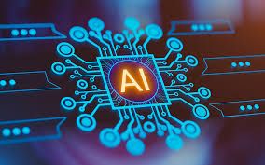
Artificial Intelligence, or AI, isn't something from science fiction anymore, it's already a part of our daily lives. We use it when we ask ChatGPT a question, unlock our phones with Face ID, or get movie recommendations on Netflix. Even if we don't notice it, AI is quietly making many everyday tasks easier.
As AI continues to grow, one question comes to mind: Is it here to help us, or will it eventually replace us?
There isn't one simple answer. AI is an amazing tool that helps us in many ways, but it has also raised concerns about jobs, creativity, and the future. Instead of being afraid of it, maybe it's better to understand what AI can and can't do.
AI Is Already Part of Our Daily Lives
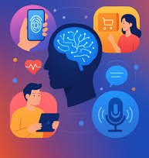
Think about how often you use your phone in a day. Every time you search for something online, ask Google Maps for directions, or get a playlist made just for you, AI is working behind the scenes.
Shopping websites suggest products you might like, social media shows posts based on your interests, and voice assistants answer your questions in seconds.
These things have become so normal that we rarely stop to think about how much AI is helping us every day.
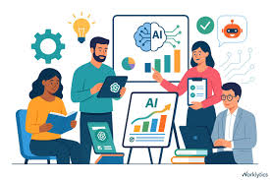
AI at Work
AI is changing the way people work too. Many companies use AI to do repetitive tasks like sorting data, answering common customer questions, or managing schedules. This saves time and lets employees focus on work that needs creativity and problem-solving.
Some people worry that AI will take away jobs, and it's true that some roles are changing. But at the same time, new jobs are also being created. Today, knowing how to work with AI is becoming an important skill.
Instead of replacing everyone, AI is becoming a tool that helps people do their jobs better.

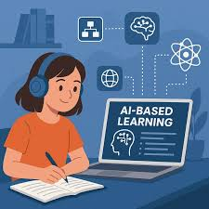
AI Is Changing the Way We Learn
Students and teachers are also seeing the benefits of AI.
AI-powered learning apps can explain difficult topics, help improve writing, and even create study plans based on what a student needs. Teachers can use AI to save time on tasks like grading or preparing lessons. But there's one thing AI should never replace learning for yourself.
Using AI to understand a topic is helpful. Using it to do all your work isn't. Real learning comes from asking questions, making mistakes, and thinking for yourself.

Humans Still Matter
No matter how smart AI becomes, there are things it simply can't do the way humans can.

It doesn't truly understand emotions. It can't replace kindness, creativity, or empathy.

For example, AI might help a doctor find signs of a disease, but it can't comfort a worried patient or make difficult decisions with compassion.
That's why AI works best when it supports people instead of replacing them.
Humans still bring something special:
- Creativity
- Empathy
- Critical thinking
- Common sense
- Emotional understanding
These are things that technology can't truly copy.

What Does the Future Hold?
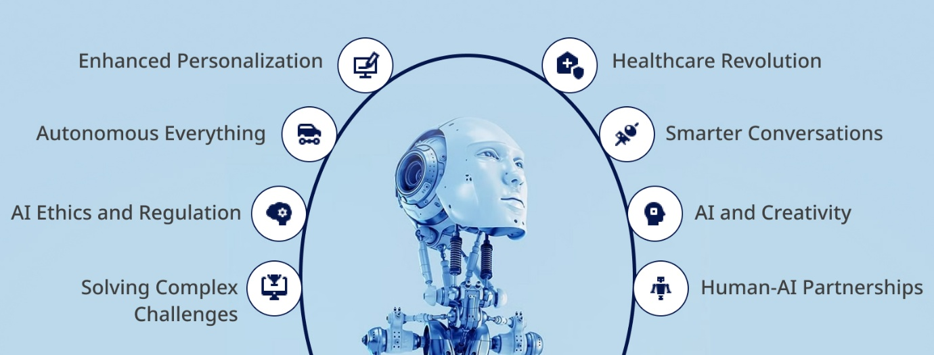
AI is improving faster than ever. In the future, we'll probably see smarter assistants, better healthcare, safer transportation, and many more exciting innovations.
But as AI becomes more powerful, we also need to use it responsibly. Privacy, fairness, and ethical use of AI will become more important than ever.
Technology should make our lives better not take away what makes us human.
Final Thoughts
So, is AI a friend, an assistant, or a replacement?
Personally, I think it's mostly an assistant.
AI can help us save time, learn faster, and become more productive. But it can't replace human imagination, emotions, or the ability to connect with others.
At the end of the day, AI is just a tool. Like any tool, its value depends on how we choose to use it.
The future isn't about humans versus AI it's about humans using AI to build a better future together.

